HALC
Childcare
Information
Brochure
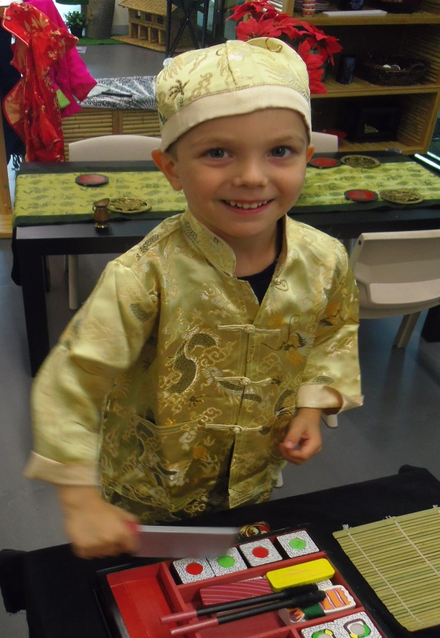
2019 - 2020

What to Bring
Babies/Toddlers:
- A change of clothes
- Nappies, wipes and plastic bags (Children are to arrive in a clean nappy, however, if during the session it is soiled or extremely wet we will change it)
- A bib or two
- Comfort item (if required), such as a toy or blanket
- Dummy in a sealed, named container (if required)
- Clearly labelled Bottle of Expressed milk, formula or cows milk (if required)-Please hand over to staff for storage and sign it in the bottle register.
- Water bottle with a lid or a Sippy cup
- A healthy snack or lunch (no nuts or nut products), in labelled containers (if on solids)
- A sun safe hat which covers your child's face, neck and ears
- Sleeping sheet set or blanket for nap time (if required)
- Any medications – please give these to centre staff to manage directly.
Older Children:
- A change of clothes (when involved with hands-on play-based learning, your child may get a little messy!)
- An extra few pairs of undies (especially if toilet training)
- A healthy snack or lunch (no nuts or nut products), in labelled containers
- Water Bottle
- A sun safe hat which covers your child's face, neck and ears
- Any medications – please give these to centre staff to manage directly.
Do I need to pack sunscreen?

It is recommended, as best practice, for you to apply sunscreen to your child before you come to childcare. If you forget, HALC childcare provides child-safe sunscreen as we are committed to being a sun safe organisation. However, if your child has sensitive skin, please feel free to pack your own preferred brand.

Above all, make sure everything you pack is clearly labelled!

On Arrival
New Parents: Before your child can attend HALC Childcare, your child’s Online enrolment(My Family Lounge) or hardcopy enrolment form must be fully completed (about 12 pages). You must also provide us with an ‘immunisation history statement’ from Medicare, showing that they are fully vaccinated, or on a catch up schedule (no jab no play legislation). Finally, we need to sight their Maternal Child Health record book and a have a copy of their Birth Certificate.
- Please wit for the Childcare sign to say ‘Open’ before entering. Upon entering the Childcare please follow the procedures below;

  - Proceed to foyer area of childcare
  - If it is busy, please wait for a staff member to open the gate.
  - New parents please provide educators with Documents (as above) and confirm your child’s enrolment form is fully completed before your child can be left in childcare.
  - Inform staff if you require a booking for next week or you can book yourself via the app earlier in the morning.

- Sign your child in on the tablet provided at the front desk.
  - This is a legal document which needs to be signed by the responsible guardian.
- Place bag in locker with your child’s name.

- Inform staff of any specific feeding and toileting requirements for staff to document on the Childcare Information whiteboard.

Bottles (already sterilized at home) must be labelled with your child’s full name. Please hand over bottles to staff on arrival to be placed in the fridge. There is a ‘bottle register’ that needs to be filled out informing staff of the type of milk and time to be given.

- Remind staff of any allergies, and if you are providing staff with an EpiPen or asthma medication.

- Inform staff if your child is being collected by someone other than yourself and record this on the Sign-In tablet. This person must be listed on the child’s enrolment form.

- Inform staff if your child’s enrolment records need updating,
such as contact numbers, address, access, emergency contacts and/or
immunisation details.

Times, Fees and Charges
(As of July 2019)

Session Times:
Session 1: 9:00am-10:30am
Session 2: 10:45am-12:15pm
Please try to be prompt when picking up your child. The 15 minute window in between the sessions allows for pickups and drop offs that may run overtime, such as, Parents attending a Pre-Scheduled Group Fitness Class till 10:30am or starting at 10:45am.
Sessional Care:
Per child per session (Member): $8.50
Per child per session (Non Member) $12.00
(Parents/guardians are to remain within the centre at all times)
Occasional Care :
Occasional Care: $19.00
(Parents/guardians are able to leave the centre)
- Our payment system consists of the set up of a 'Family account' with an amount similar to a 10 pass (using prices above). This is paid at reception and the docket brought into childcare to add to your QikKids account. Each week you will receive a statement detailing usage, debits, payments and overall balance. This will prompt you to make a payment at frontline if your balance is low.

Occasional Care
Occasional care is available all hours during Childcare times.

Monday- Friday: 9:00am – 12:15pm

Minimum: 1 ½ hours per day
You may book for 1 ½ hours, during the 1st or 2nd sessions (9:00-10:30am or 10:45-12:15pm) or you can book for 3 hours (9:00-12:00pm or 9:15-12:15pm) going over both sessions.

Maximum: 15 hours per week
This allows you to leave your child in care whilst you attend to matters away from the centre. It is a good opportunity for you to make appointments.

Bookings can be made 7 days in advance.
For all other session times you are required to remain in the centre.

Cost: 1 child per 1 ½hr session: $19.00

Child Protection

Providing a Child Safe Environment

The YMCA is committed to providing a safe and secure environment for children where children feel safe, empowered and confident. It is our Duty of Care to ensure we actively promote a child safe organisation with an adequate level of protection against harm. Before employment can commence a prospective staff member must ensure they have a current and valid Working with Children Check, a current clear Police Records Check, First Aid qualifications and Anaphylaxis Awareness Certificate. A Comprehensive recruitment process is conducted and pre-employment reference checks (non-family members) will also be conducted.

To ensure a child safe organisation the YMCA will:

- Ensure all new staff and casual relievers undertake a thorough recruitment, selection and orientation process.

- Ensure that at all times the service complies with the regulated staffing requirements as outlined in the Children Services Regulations and that there are two staff members on duty when opening and closing the childcare service.

- Staff will at all times actively and effectively supervise children and maintain child staff ratios.

- Provide up to date information and access to professional development for staff.

- Provide information and resources for families on Child Protection issues, concerns and where to access help and further information.

- Be alert to the risks and signs of abuse and neglect and reporting procedures.

- Follow the appropriate procedures for documenting and reporting concerns.

Child Protection Policy:

Statement of intent

“Mankind owes to the child the best it has to give.”
United Nations Convention on the Rights of the Child 1989.

YMCA Victoria recognises that all children and young people have the right to develop and reach their potential in environments that are caring, nurturing and safe. YMCA Victoria considers any form of child/young person abuse, inclusive of

emotional, physical, sexual abuse or neglect, as intolerable under any circumstances. YMCA Victoria has a legal, moral and Mission-driven responsibility to protect children and young people from harm and to ensure that any incidents of suspected child abuse are promptly and appropriately dealt with.

Policy principles

Please note: in the context of this policy & procedures document, the term ‘child’ refers to both child and young person under the age of eighteen.

- The safety of children and young people is paramount.

- Children and young people need to know and believe that they have the right to be and feel safe at all times.

- Child abuse is abhorrent and illegal and must never be tolerated or ignored.

- Staff and volunteers of YMCA Victoria are entrusted to ensure that the people who care for children and young people act in the best interests of the child and take all reasonable steps to ensure the child’s safety.

e) Staff and volunteers of YMCA Victoria will show a commitment to educating children and young people about self-protection and promote resilience and empowerment strategies within its programming.

Source: YMCA Victoria, Safeguarding children and young people policy and procedures

Reporting Child Abuse

The Centre Manager can make a notification to the Department of Human Services Child Protection Unit where it is considered under reasonable grounds that a child is in need of protection.
A child report can be made when there is:

- A significant concern for a child’s wellbeing
- A belief the child is in need of protection
- A disclosure has been made by a child

Childcare Cancellation Policy

The convenience of the ‘Family Lounge’ app means you can cancel your child out at any time before 9:00pm the day prior to your booking. It is helpful to give 24 hours’ notice but we understand that this is not always possible so at the latest by 9:00pm the day before you wish to cancel.
Please note: By cancelling on time, via the app, enables other parents to take your place. It also allows the Childcare team to make sure we have adequate staff for the numbers.
Failure to co-operate with this policy or not showing up for a booked session will result in the booked session being charged and debited from your family account.

Please note: When booking, if you find the sessions are full (red strip on calendar day), we do have a waitlist at frontline. You can place your child’s name on the waitlist and if a space becomes available they will contact you. If there are a few children on the waitlist I may be able to open the numbers and put another staff member on.

Your co-operation is appreciated.

Please keep your child at home if she/he has:
- A temperature in the morning.
- Conjunctivitis - eye infection sometimes referred to as “pink eye”. The eye may be red with some burning and thick yellow discharge may be visible. Conjunctivitis is very contagious.
- Bronchitis -may begin with hoarseness and slightly raised temperature. The cough may be dry and painful but gradually become productive. Bronchitis is a serious disease in children as it may develop into pneumonia.
- A rash that has not been identified diagnosed and treated by a doctor.
- Impetigo (school sores) - shows as red pimples which become weeping sores when blister breaks. Occurs most frequently in moist areas of the body, e.g. neck groin, mouth/face, etc. Impetigo is very contagious.
- Diarrhoea - bowel movements that look different and are more frequent and vomiting. Keep your child at home for at least 12 hours after the occurrences of either diarrhoea or vomiting. Gastric Infections are easily transferred amongst children (and staff).
- A severe cold, a fever, is sneezing or has nose drainage.
- Any contagious disease: measles, mumps, chicken pox, etc.
- An ear or throat infection and is on an antibiotic. The child should not be brought in until he/she has medication for at least 24 hours.
- Ringworm - unless treated and cleared by a doctor as no longer infectious.
Please note: If a child becomes ill after admission to the childcare, staff are advised to contact the parent/guardian immediately. The child is unable to remain in childcare once the parent/guardian has been notified.

Sleep & Rest Policy

Due to the increased risk associated with children sleeping in prams in childcare facilities, we have taken the following steps to conform to the Children’s Service Regulations 2009, regulation #103.

- Cots are provided for children requiring sleep whilst in our care.

- Linen is also provided (as we have a washing machine/dryer) you may however; provide your own bed linen for your child.

- All prams will be kept in the foyer as they take up our floor space which restricts the number of children we can care for.

- A pram is not a suitable place for babies to sleep if unobserved. If a baby only settles while in the pram, educators will remain with the baby and when the baby is asleep, then place baby into a safe cot.

- Supervision will remain constant and active.

It is important that we reiterate that our priority is first and foremost with each child’s safety and wellbeing.

For more information on safe sleeping practices please visit the website https://rednose.com.au/
https://www.acecqa.gov.au/safe-sleep-and-rest-practices

Kind regards,
Alicia Tsakmakis
Childcare Team Leader

On Departure

- Upon entering the childcare to collect your child please follow the procedures below:

  - Proceed to foyer area of childcare.
  - Wait for a staff member to open the gate.

- Collect your child and their belongings.

- Sign your child out on the Sign In/Out Tablet.

  - This is a legal document which needs to be signed by the responsible guardian.
- Once you have signed out your child it is your responsibility to leave the childcare room.

- A childcare staff member will open the gate for you to allow you to depart.

- Please make sure your account has sufficient funds in it for the following few weeks. If not, please top up at the reception desk, located in the front foyer, and then bring your receipt into childcare to be added to your family account.

Contact us:

Address: 1 Grace Street, Hawthorn, VIC 3122

Website: www.hawthorn.boroondaraleisure.com.au

Email for Childcare: HALC.childcare@ymca.org.au

To Book:
After you have registered and your child has been enrolled on the QikKids system please use your 'My Family Lounge app: OR phone (03) 8393 9500 during business hours.

Centre Opening Hours:

Monday - Friday: 6:00am - 9:30pm

Saturday: 7:00am - 8:00pm

Sunday: 8:00am - 8:00pm

NOTE: Public holiday opening hours are as advertised.

